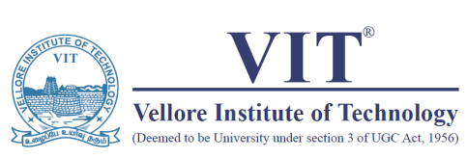

OFFICE OF STUDENTS’ WELFARE

Event Report 2019

|  |  |  |  |
| --- | --- | --- | --- |
| Club-Chapter Name | IEEE SPS | | |
| Event Name | MATLAB WORKSHOP | Date | 08/02/2019 |
| Venue | TT - 205 | No. of Participants | 30 |
| Event Description |  | | |
| The sole purpose of the workshop was to introduce students to computer vision and get familiarized with a few basic concepts of deep learning and machine learning.  What was taught t the students was basically how face recognition leverages computer vision to [extract discriminative information](https://in.mathworks.com/discovery/feature-extraction.html) from facial images, and [pattern recognition](https://in.mathworks.com/discovery/pattern-recognition.html) or machine learning techniques to model the appearance of faces and to classify them.  To keep the students engaged, we started off with a simple program that detects a face and tracks it till the program is terminated, and through this program, we made clear the concepts of facial detection and recognition using the KLT algorithm. | | | |
| Collaborating Agency/Club/Chapter/Others: None | | | |
| Photo | | | |
|  | |  | |
|  |  |  |  |
| Student Coordinator | Faculty Coordinator | Asst. Director SW | Director SW |
| Name: Sandhya S | Name: Vaegae Naveen Kumar |  |  |
| Reg. No. 16BEC0291 | Emp. ID: 13737 |  |  |